

ASSIGNMENT-2
Web Programming using
Python and JavaScript

Submitted by: Submitted to:
Name: Dev Bhardwaj Name: Ms. Mansi Kajal
Course: B.Tech CSE(Core)-B
Roll no: 2401010082

Event Management
AIM: To design and develop a fully functional Event Management
Website using HTML, CSS, JavaScript (front-end) and Python Flask (back-end), enabling users to create, browse, register for, and manage events through a dynamic and responsive web interface.

LEARNING OBJECTIVES:
By the end of this experiment, students will be able to:
- Understand the role of Flask as a lightweight Python web framework.
- Integrate front-end technologies (HTML5, CSS3, JavaScript) with a Flask back-end.
- Create RESTful routes and render dynamic templates using Jinja2.
- Handle HTML forms and manage data using Flask session or a simple database.
- Apply responsive design principles to build a user-friendly event portal.
- Implement CRUD (Create, Read, Update, Delete) operations for event management.

Frontend Codes: base.html:
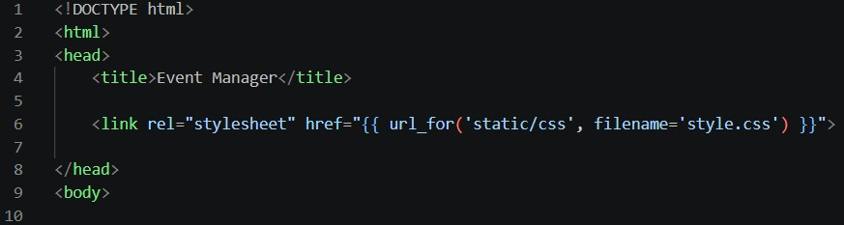
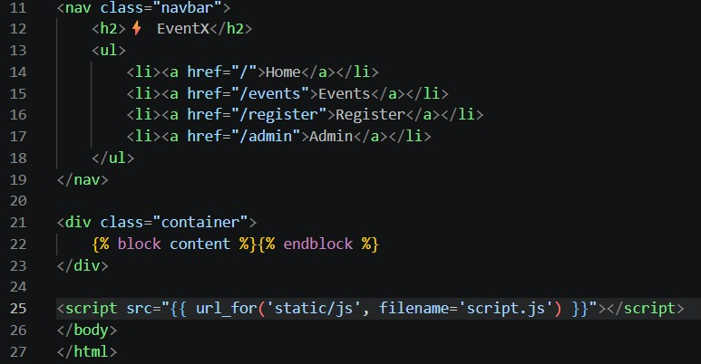

index.html:
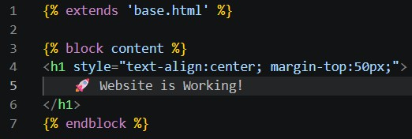
events.html:
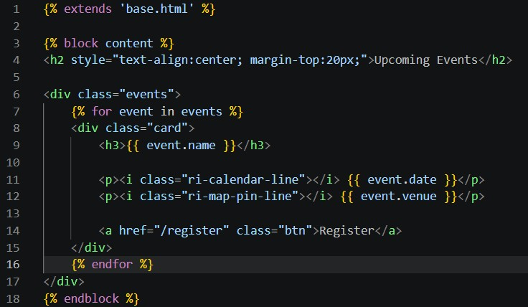
register.html:
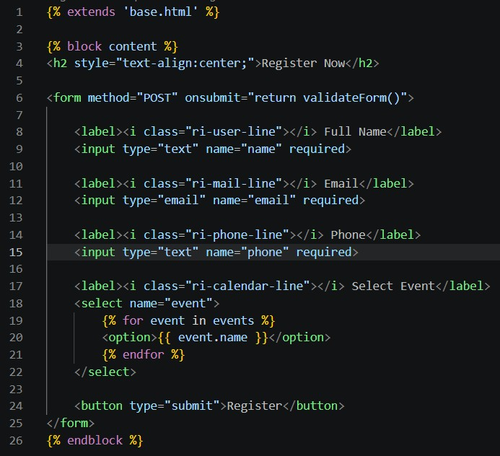
admin.html:
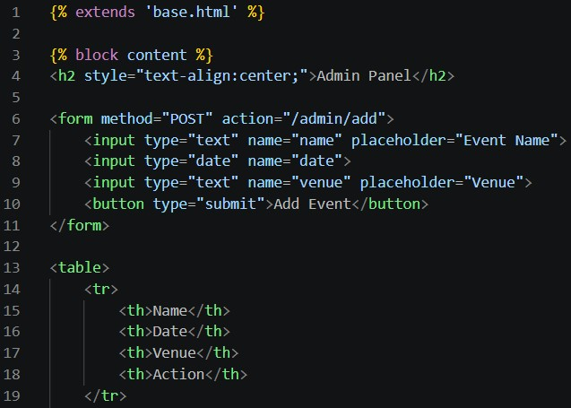
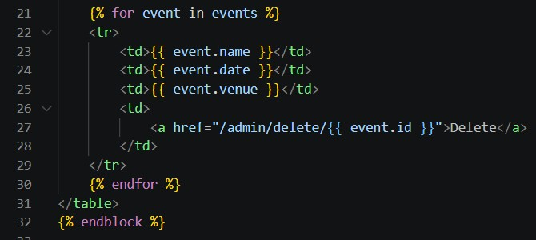

style.css:
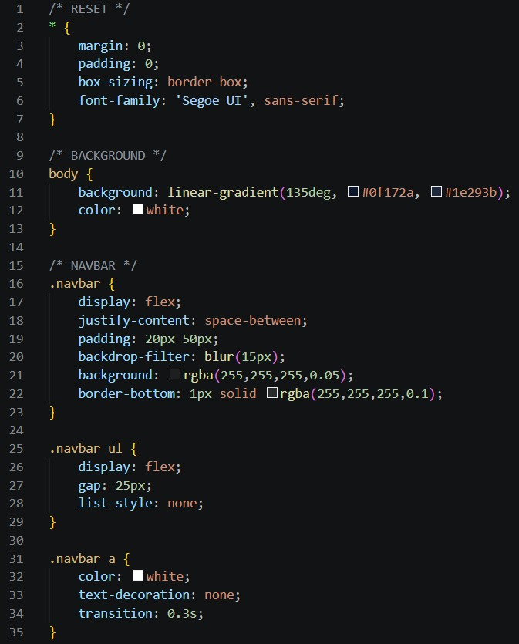
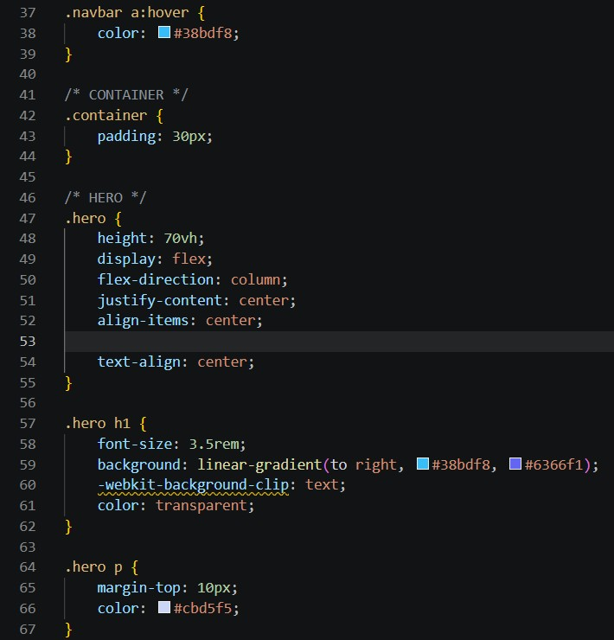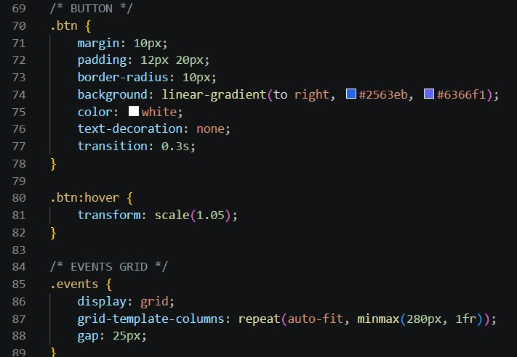

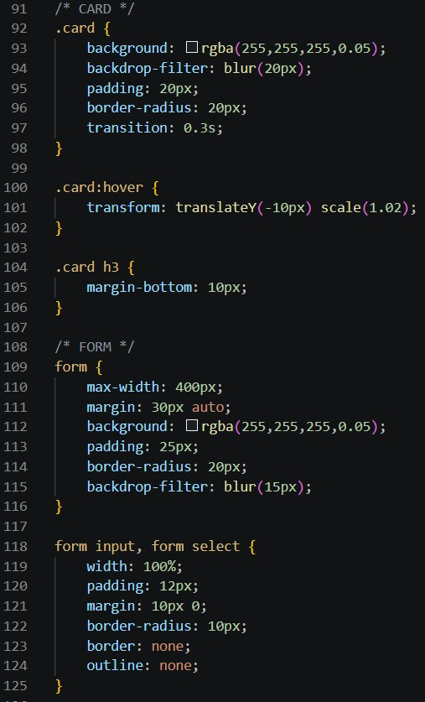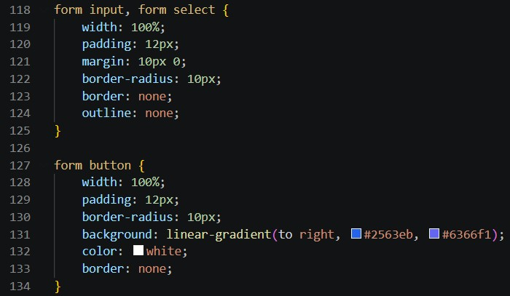

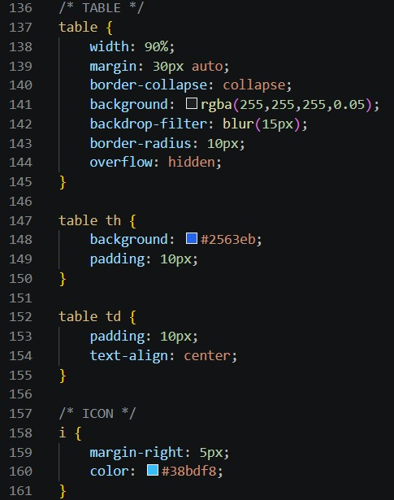
script.js:
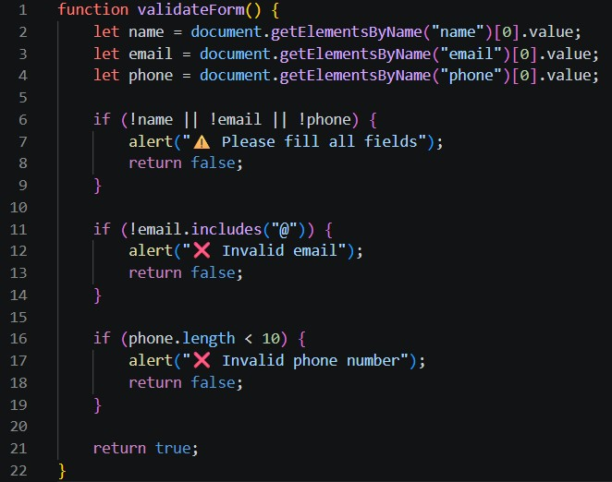
Backend Codes: app.py(flask):
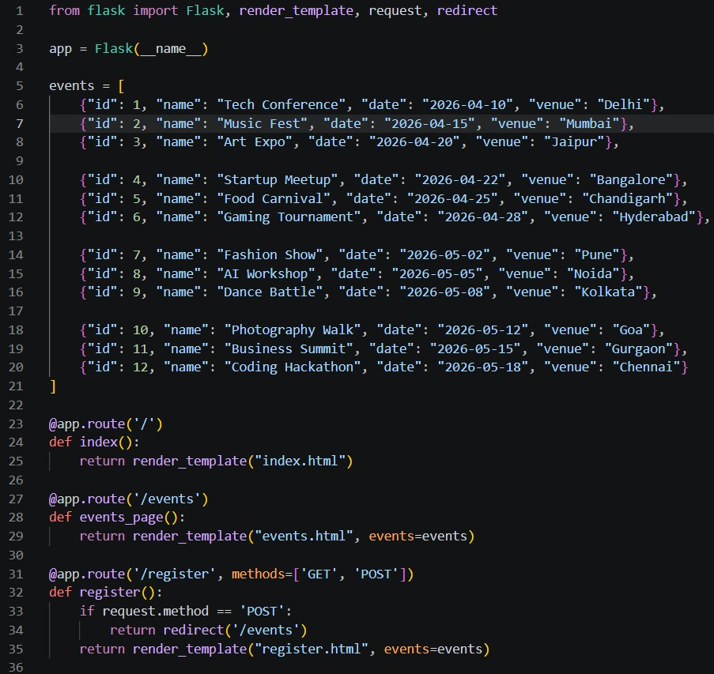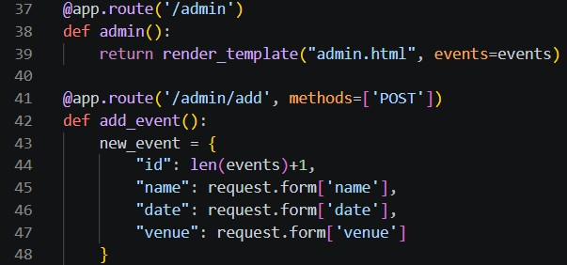

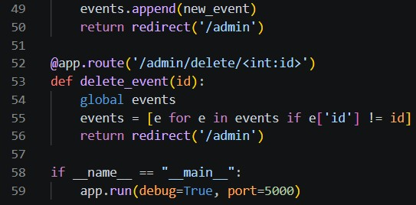

Outputs:
